**CREATIVE EDUCATIONAL SERVICES KAMPALA**

**MID-TERM I EXAMINATIONS 2024**

**MATHEMATICS**

**PRIMARY SEVEN**

***Time allowed: 2hours 30 minutes***

|  |  |  |  |  |  |  |  |  |
| --- | --- | --- | --- | --- | --- | --- | --- | --- |
| **Random No.** | | | | | | **Personal No.** | | |
|  |  |  |  |  |  |  |  |  |

**Candidate’s name: ………………………………………………………….**

**Candidate’s Signature: ……………………………………………………**

|  |  |  |  |
| --- | --- | --- | --- |
|  |  |  |  |

**District ID:**

|  |  |  |
| --- | --- | --- |
| **FOR EXAMINERS’**  **USE ONLY** | | |
| **Qn. No.** | **MARKS** | **EXR’S**  **No.** |
| **1- 5** |  |  |
| **6 -10** |  |  |
| **11- 15** |  |  |
| **16 – 20** |  |  |
| **21 – 22** |  |  |
| **23 – 24** |  |  |
| **25 – 26** |  |  |
| **27 – 28** |  |  |
| **29 – 30** |  |  |
| **31 – 32** |  |  |
| **TOTAL** |  |  |

**Read the following instructions carefully:**

1. Do not write your **school** or **district name** anywhere on

this paper.

1. This paper has two sections **A** and **B**. Section **A** has **20**

**questions** and **section B** has **12 questions** .This paper

has **12 pages** printed altogether.

1. Answer **all** questions. All the working for both sections

**A** and **B** must be shown in the spaces provided.

1. **All** working must be done using a **blue** or **black** ball

point pen or ink. Any work done in pencil other than

graphs and diagrams will **NOT** be marked.

1. **No calculators** are allowed in the examination room.
2. Unnecessary **changes** in your work and handwriting

that cannot be easily read may lead to loss of marks.

1. Do not fill anything in the table indicated **“For examiners’ use only”** and the boxes inside the question paper.

**Turn Over**

**SECTION A : (40 MARKS)**

1. Workout: 45 – 17
2. Write **“Fourteen thousand, forty”** in figures.
3. Simplify: 3w – (w-2)
4. Round off 4.46 to the nearest tenth.
5. Given that 2p + 200, 300 and 900 are angles on a straight line.

Find the value of p.

1. Victor had his lunch at the time shown on the clock face below. At what time did he have his lunch?

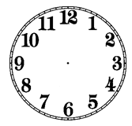

1. The mean of y, 5, 3 and 2 is 3. Find the value of y.
2. Given that M = { multiples of 4 less than 20}. Calculate the number of subsets in set M.
3. Convert 8ten into a binary base.
4. Using a pair of compasses, ruler and a very sharp pencil only, construct an angle of 1350 in the space below.

1. The cost of 3kg of maize flour is sh. 7,500. If Moses paid sh. 125,000 for a sack of maize flour at the same rate, calculate the weight of the sack of maize flour.
2. After selling a phone at sh. 90,000, Kibirige realized a loss of sh. 30,000. What was the cost price of the phone?
3. Given that a is a third of b and b = 2. Find the value of a + b
4. Muwanguzi has 7 T. shirts and 5 shirts in his suitcase. Calculate his probability of selecting a T. shirt at random from the suitcase.
5. Find the biggest number of pupils who can be given 12 or 15 apple and no apple remains.
6. The price of a watermelon was decreased from sh. 5000 to sh.4000. Calculate the percentage decrease in the price of the watermelon.
7. Convert 10m/second into km/hr.
8. The temperature of juice in a fridge dropped by 3°C to -5 0C. What was the old temperature of juice?
9. A farmer planted 100 eucalyptus trees in his garden in a straight line. The distance from one tree to another tree was 600cm each. Calculate the distance from the first to the last tree in metres.
10. The base area of a rectangular box is 40cm2. Find its height if it has a volume of 200cubic centimetres.

**SECTION B: (60 MARKS)**

1. At a wedding ceremony, 34 guests were invited. 15 guests ate meat (M), 20 guests ate fish(F), y guests ate both fish and meat while 2 guests did not eat any of the two dishes.
2. Use the above information to complete the venn diagram below.

n(∑) = 34 ***(2marks)***

n(F) n(M)=15

______ y _______

2

1. How many guests did not eat fish? ***(3marks)***
2. Given the digits 4, 0, 6
3. Write all the possible 3-digit numbers that can be formed using all the above digits. ***(2marks)***
4. Find the sum of the largest and smallest 3-digit numbers formed in question 22(**a**) above. ***(2marks)***
5. The sum of 3 consecutive counting numbers is 24. If the first number is k. find the value of k. ***(2marks)***

b) The LCM of two numbers is 36 and their GCF is 6, find the first number if the second number is 18. ***(2marks)***

1. Study the number line below and use it to answer the questions that follow.

X

W

-7 -6 -5 -4 -3 -2 -1 0 +1 +2 +3 +4 +5 +6 +7 +8

Y

1. Name the integers represented by; ***(1mark@)***
2. Y = (ii) W=

(iii) X =

1. Write down the mathematical sentence for the above number line.

***(2marks)***

1. A certain school, the number of pupils who reported on the first day for term one in P.7 , P.6 and P.5 was in the ratio of 3: 5: 2 respectively.

If 18 more pupils reported in P.6 than P.7, how many pupils reported in each class? ***(6marks)***

1. Solve 23k ÷ 8 = 1 ***(2marks)***

b) Solve the inequality; 7 < 3p – 2 < 16 and find the solution set.**(3marks)**

1. Stella bought the items as shown in the table below.

|  |  |  |  |
| --- | --- | --- | --- |
| **Item** | **Quantity** | **Unit cost** | **Total cost** |
| Meat | 1 ½ kg | Sh. 15,000 | Sh. _____________ |
| Sugar | 3kg | Sh. _______________ | Sh.14,400 |
| Soap | ____________bars | Sh. 6, 500 | Sh.19,500 |
|  | Total expenditure | | Sh.______________ |

1. Complete the table above.  ***(4marks)***
2. If she remained with sh. 3,600 after buying all the items, how much money did she have at first? ***(2marks)***

1. Dannah filled of a tank with water. The tank had a diameter of 70cm and height of 100cm. Calculate the litres of water needed to fill the tank to its full capacity. ***(5marks)***

1. In a basket of 45 eggs, 20% of them are bad eggs and the rest are good eggs.
2. How many good eggs are in the basket? ***(3marks)***
3. Express the number of bad eggs as a fraction of all the eggs in the lowest term. ***(2marks)***
4. At a stationary, the cost of a pen is twice the cost of a pencil. The cost of a book is sh. 1,200 more than the cost of a pen. If Deborah paid sh.900 for a pen and a pencil, how much will she pay for the two books? ***(5marks)***

1. Using a pair of compasses, ruler and a pencil only;
2. Construct a square ABCD whose one side is 5.4cm ***(4marks)***
3. Measure diagonal AC = ______________cm **(1mark)**

1. A cyclist left home for town at 7:00a.m using a speed of 50km/hr for 2 hours. He found traffic jam which took 1 ½ hours. He later continued to town using a speed of 32km/hr for 2 ½ hours.

(a) Use the above information to show the cyclist journey on the graph below. **(3marks)**

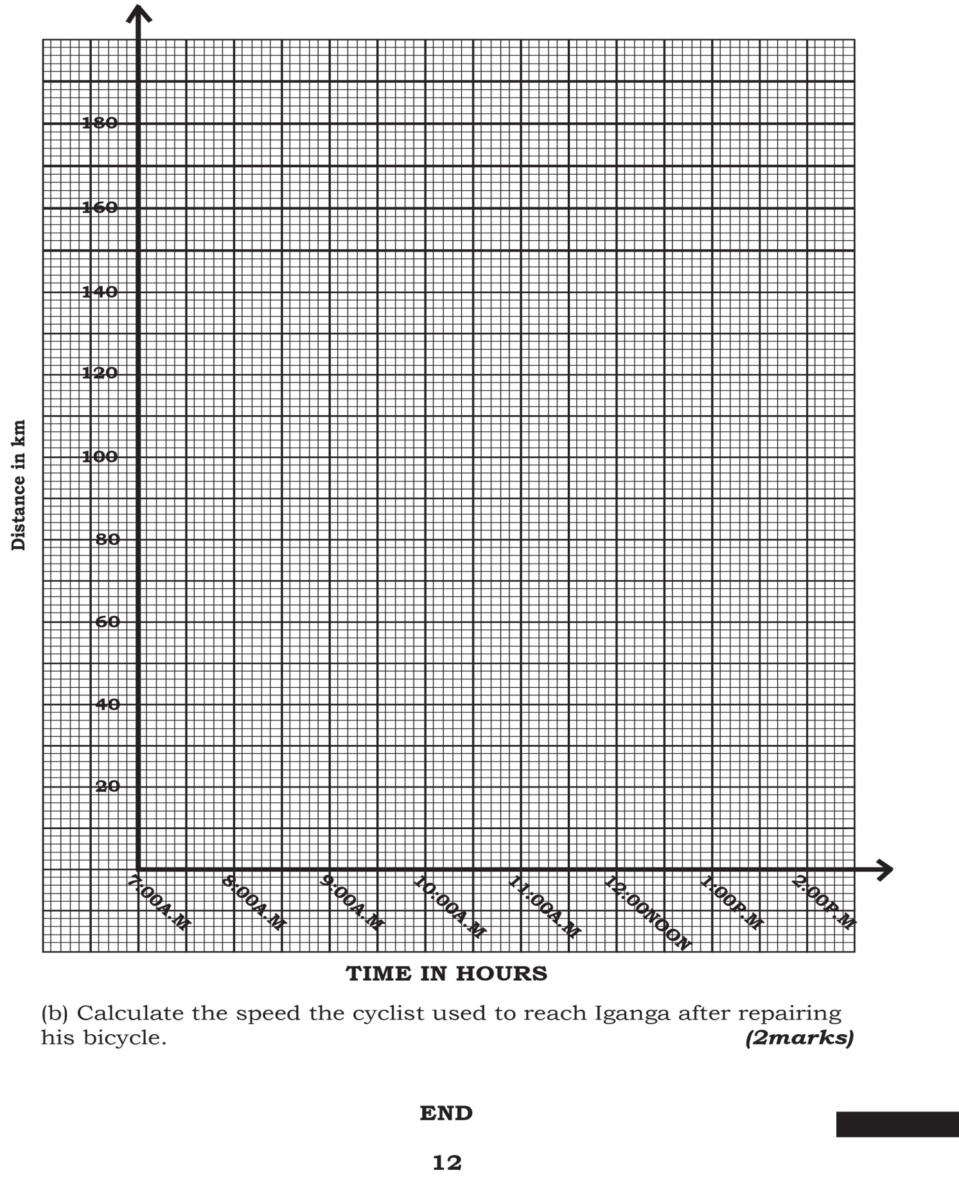

b) Calculate the average speed for the whole journey.

***(2marks)***